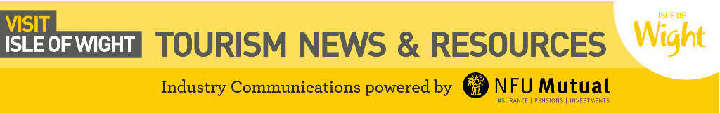

Simon Clark, Visit Isle of Wight: simonc@visitwight.org t: 01983 240090 m: 07495 408226

The best things in life are free…

- Stargazing under the Island dark skies https://www.visitisleofwight.co.uk/things-to-do/dark-skies

- Go wildlife spotting – red squirrels, white tailed eagles, rare butterflies, moths, dolphins and seals have all been spotted here

- Beaches https://www.visitisleofwight.co.uk/things-to-do/beaches

- Walks https://www.visitisleofwight.co.uk/things-to-do/walking

- Cycling https://www.visitisleofwight.co.uk/things-to-do/cycling

- IW Donkey Sanctuary https://www.visitisleofwight.co.uk/things-to-do/isle-of-wight-donkey-sanctuary-p136321

- Fossil hunting on the beach https://www.visitisleofwight.co.uk/things-to-do/attractions/dinosaurs-and-fossils

- Quarr Abbey https://www.visitisleofwight.co.uk/things-to-do/quarr-abbey-p911291

- IW Bus and Coach Museum https://www.iwbusmuseum.org.uk/

Visit Isle of Wight
Working in partnership with Visit England, Visit Isle of Wight Ltd (VIOW) is responsible for developing tourism and attracting more visitors to the Isle of Wight. As well as the consumer website www.visitisleofwight.co.uk the DMO also operates a small industry website containing recent research and tourism news along with links to Visit England reports and opportunities www.visitwightpro.com
Go to https://www.facebook.com/VisitIOW
https://twitter.com/VisitIOW
https://instagram.com/visitisleofwight/
https://www.youtube.com/user/VisitIsleofWight

